Activity 1

Replicate data of their sample files.

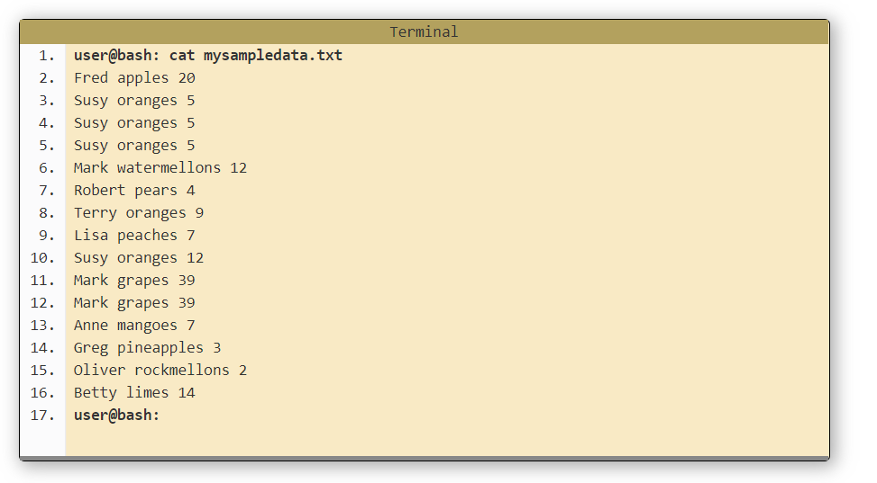

Activity 2

Do each of the commands that was in the tutorial.

I executed all nine commands that was in this chapter and have them all in a folder along with this readme file.

Activity 3

Find at least two options with these commands and use them. My output is in a folder along with this readme file.